H.T No
Regulations:
A17

Sreenidhi Institute of Science and Technology
(An Autonomous Institution)
Code No: 6A201 Date: 28-Mar-2023 (AN)

B.Tech I-Year II- Semester External Examination, March/April-2023 (Supplementary)
CIRCUITS AND NETWORKS – I (EEE)

Time: 3 Hours Max.Marks:75
Note: a) No additional answer sheets will be provided.
b) All sub-parts of a question must be answered at one place only, otherwise it will not be valued.
c) Missing data can be assumed suitably.

Bloom's Cognitive Levels of Learning (BCLL)

Remember | L1 | Apply | L3 | Evaluate | L5
Understand | L2 | Analyze | L4 | Create | L6

Part - A Max.Marks:25

Answer all QUESTIONS.
 |  | BCLL | CO(s) | Marks
1 | What is the difference between an Independent and Dependent Sources? | L1 | CO1 | [2M]
2 | State Ohms law. | L2 | CO2 | [2M]
3 | What is the Faraday’s Law of Electromagnetic Induction? | L1 | CO3 | [2M]
4 | What is self and mutual inductance? | L1 | CO4 | [2M]
5 | What is power factor? | L1 | CO5 | [2M]
6 | Draw the current locus of a Series RL circuit with L variable. | L2 | CO6 | [3M]
7 | Explain briefly about dot convention. | L3 | CO2 | [3M]
8 | State Compensation Theorem. | L2 | CO4 | [3M]
9 | What is bandwidth? | L1 | CO5 | [3M]
10 | Write short notes on Duality. | L2 | CO6 | [3M]

Part – B Max.Marks:50
ANSWER ANY FIVE QUESTIONS. EACH QUESTION CARRIES 10 MARKS.

 |  |  | BCLL | CO(s) | Marks
11. | a) | Determine I_{o} in the circuit.  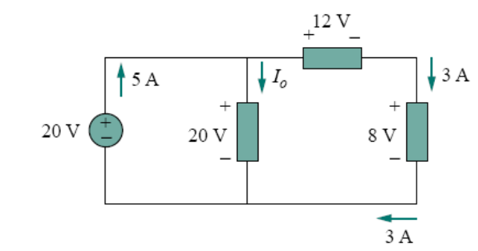 | L4 | CO1 | [5M]
 | b) | Determine v₁ and v₂ in the circuit.  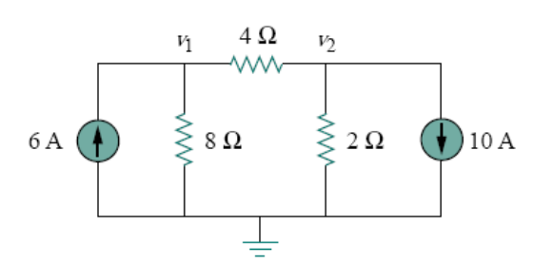 | L4 | CO1 | [5M]
12. | a) | Draw the dual of a network shown in fig.  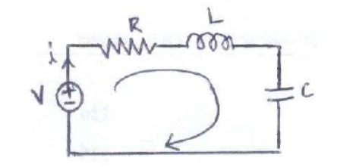 | L3 | CO2 | [5M]
 | b) | For the network shown in fig. Write a tie set schedule and then find all branch currents and voltages.  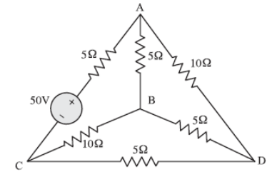 | L3 | CO2 | [5M]
13. | a) | Find the inductance of an ideal solenoid with 200 turns, l= 0.50 m and a circular cross section of radius 0.05m. | L3 | CO3 | [5M]
 | b) | Find v_{o} in the circuit.  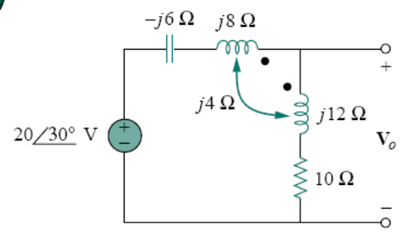 | L3 | CO3 | [5M]
14. | a) | Determine v(t) and i(t) in the circuit.  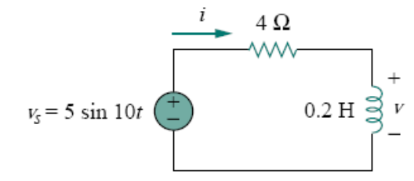 | L3 | CO4 | [5M]
 | b) | Find the rms value of current wave form shown in fig? If the current flows through a 9 ohm resistor, calculate the average power absorbed by the resistor.  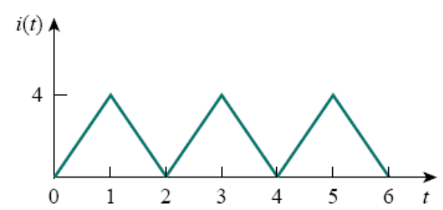 | L3 | CO4 | [5M]
15. | a) | In the series RLC circuit R=2Ω, L = 1 mH, and C= 0.4µF. (i) find the resonant frequency and half power frequencies. (ii) Calculate the quality factor and bandwidth (iii) determines the amplitude of the current at ω₀, ω₁ and ω₂?  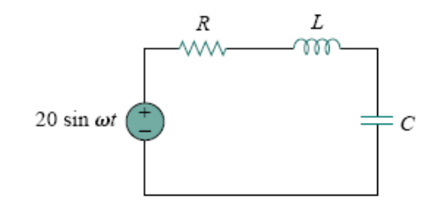 | L5 | CO5 | [5M]
 | b) | Draw the locus diagram of a series RLC circuit with L and C varying? | L3 | CO5 | [5M]
16. | a) | Find the maximum power that can be delivered to the resistor R in the circuit.  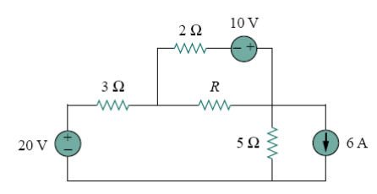 | L3 | CO6 | [5M]
 | b) | Find the thevenins equivalent circuit at the terminals a-b.  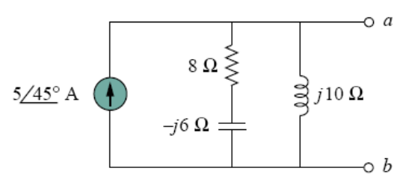 | L3 | CO6 | [5M]
17. | a) | Use mesh analysis to find the current i_{o} in the circuit shown in fig.  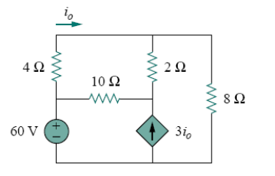 | L3 | CO1 | [5M]
 | b) | Determine the inductance of the three series connected inductors.  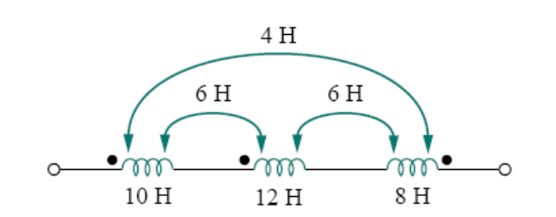 | L5 | CO2 | [5M]
18. | a) | Derive the relationship between resonant frequency, quality factor and bandwidth. | L3 | CO4 | [5M]
 | b) | Determine the power factor of the entire circuit as seen by the source. Calculate the average power delivered by the source.  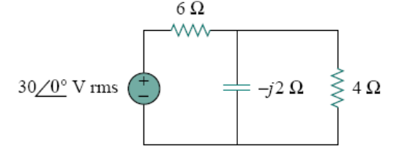 | L5 | CO5 | [5M]

-- 00 -- 00 –

